NORTHEAST KANSAS CHAPTER
SCHOLARSHIP COMMITTEE
Sergeant at Arms Anita Cole
Officer Edward Chacon
3rd TBD

OF THE
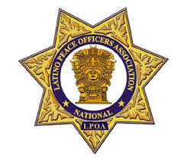
2025 SCHOLARSHIP APPLICATION
APPLICANT INFORMATION
NAME ____________________________________________ AGE _______
PARENTS NAME _______________________________________________________
ADDRESS _________________________________________________________________
CITY _______________________ COUNTY ________ STATE ______ ZIP __________
Phone_____________ E-MAIL_____________________________________
Name of High School______________________________________ GPA_______
You are required to provide to the following with this application:
- Proof of volunteer/community service
- 500 word essay detailing educational and career goals
- Proof of college enrollment
- Awards, recognition from community, school
- 2 Reference letters
- Copy of High School transcript
Applications are due by July 1, 2025. Contact person is Captain Osvaldo Navarro: onavarro@kckpd.org, P.O. Box is 12698, Kansas City, Kansas 66112

